

**Fundamentals of Programming Hometask 6**

**Name: Muhammad Amad Naeem**

**Section: ME-15 B**

**CMS ID: 467469**

**Task 1:**

**#include<iostream>**

**using namespace std;**

**int main(){**

**int sum=0,factors=0;**

**for(int i=2;i<=50;i++){**

**for(int k=1;k<=i;k++){**

**if(i%k==0){**

**factors++;**

**}**

**}**

**if(factors==2){**

**sum=sum+i;**

**}**

**factors=0;**

**}**

**cout<<" sum of all the prime numbers from 1 to 50: " <<sum;**

**return 0;**

**}**

**Output:**

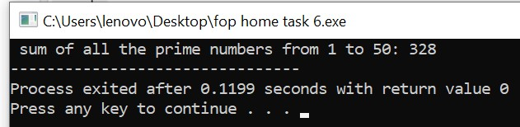

**Task 2:**

**#include<iostream>**

**using namespace std;**

**int main(){**

**for(int i=1;i<=5;i++){**

**for(int k=i;k<=i;k++){**

**cout<<1;**

**}**

**for(int j=2;j<=i;j++){**

**if(j==2){**

**cout<<2;**

**}**

**}**

**for(int a=3;a<=i;a++){**

**if(a==3){**

**cout<<3;**

**}**

**}**

**for(int z=4;z<=i;z++){**

**if(z==4){**

**cout<<4;**

**}**

**}**

**for(int s=5;s<=i;s++){**

**cout<<5;**

**}**

**cout<<endl;**

**}**

**return 0;}**

**Output:**

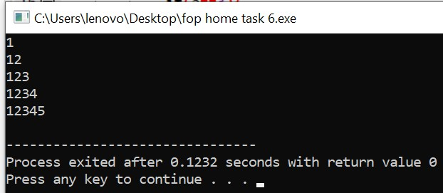

**Task 3:**

**#include<iostream>**

**using namespace std;**

**int main(){**

**for(int i=1;i<=5;i++){**

**for(int a=1;a<=i;a++){**

**if(i==1){**

**cout<<1<<endl;**

**}**

**}**

**for(int j=0;j<=i;j++){**

**if(j<=i&&i<=1){**

**cout<<2;**

**}**

**}**

**cout<<endl;**

**for(int k=-2;k<=i;k++){**

**if(k<=i&&i<=1){**

**cout<<4;**

**}**

**}**

**cout<<endl;**

**for(int z=-4;z<=i;z++){**

**if(z<=i&&i==1){**

**cout<<6;**

**}**

**}**

**}**

**return 0;}**

**Output:**

